Identifying the top five products, globally, for every year.

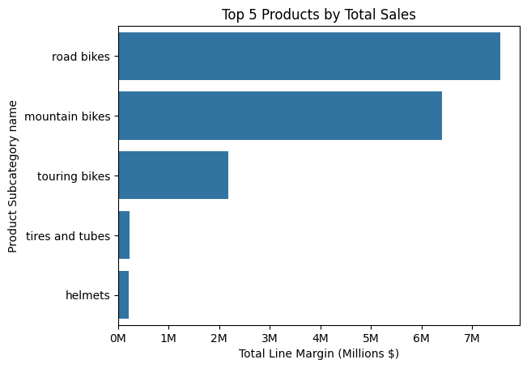

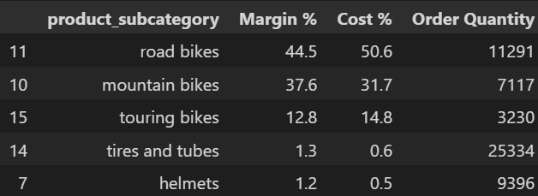

Was going to do top 5 products, but can’t do YOY analysis if there were years where the product was not sold. Hence, I looked at product subcategory instead. We see really two major product categories, road and mountain bikes.

Well nah… they’re a bike manufacturer, obviously their biggest products are the bikes.